Congregational Church of
Westminster West, UCC
Ordinary Time – November 8, 2026

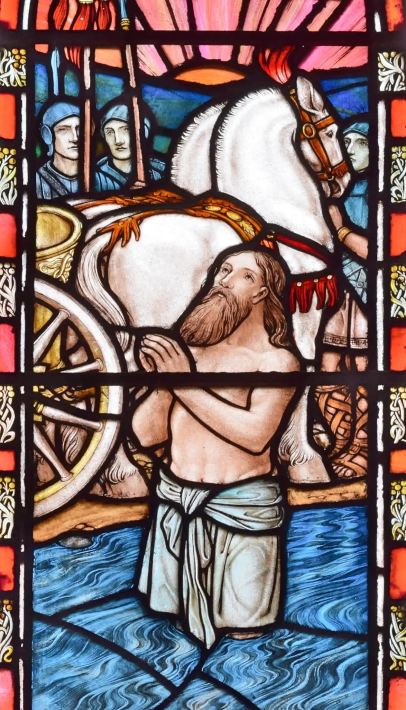
Naaman Bathes in the Jordan
by Paul Woodroffe (1923)
WELCOME AND ANNOUNCEMENTS

PRELUDE Serenade - Franz Schubert

CALL TO WORSHIP
Leader: God is a healer, the One who mends the fractures in our lives.
People: We give thanks for God’s healing love that makes us whole!
Leader: God is a spiritual physician who tends to our ailments; God redirects our life force so it can begin and end in them.
People: We rejoice in being reunited to God and restored most deeply!
Leader: Even when God’s medicine tastes bitter, it is a balm for the soul, a salve for the heart, a comfort for the mind, and a solace for the body.
People: May we trust in God, even when they confound us, so that we may become well in the holiest sense! Amen!
HYMN #597 Shall We Gather at the River

CALL TO CONFESSION
People: God, we confess that healing can feel like an affront to our egos. We shouldn’t need help, we shouldn’t be unwell, and healing shouldn’t be easy. Where’s our pride and reward in any of that? Remind us, O God, that our wellness and unwellness are not for us but for the mysterious process by which you continuously bless creation.

ASSURANCE OF PARDON
Leader: Blessedly, when we stop trying to prove ourselves, God’s love is proven true. Our God works miracles; all they ever need to do so is the miracle of our humility. Let us therefore relinquish expectations and ego-efforts, that God may carry us on the waters of love to the shores of their kin-dom. Amen.
“GLORIA”

MANNA OFFERING

Invitation to Offering
Leader: We are called to witness to the abundance in our life by sharing, so that all may have enough.
People: Just as God provided manna for God’s children daily so will our daily needs be met.
L: We offer our gifts from God’s abundance to our neighbors who live in scarcity, because it is God’s desire that no one go hungry.
P: We give, giving thanks for the blessings we are now able to share.

CALL TO SHARE
WORDS OF SHARING (unison) Isaiah 58: 1-2
If we feed the hungry from God’s plenty and satisfy the needs of the wretched, then our light shall rise like dawn out of darkness and our dusk be like noonday. We shall be like a well-watered garden, like a spring whose waters never fail.
Hymn for Sharing “Bread in the Wilderness”
(Bring your offering for Our Place forward during the singing of the hymn, put it in the basket on the table, and return to your seat.)

PRAYERS OF THE PEOPLE
Leader: May the Lord be with you.
People: And also with you.
Leader: Let us pray.

JOYS & CONCERNS, SILENCE, PASTORAL PRAYER
LORD’S PRAYER
Our Father/Mother/Creator, who art in Heaven, hallowed be Thy name, Thy kingdom come, Thy will be done, on earth as it is in heaven. Give us this day our daily bread; and forgive us our trespasses, as we forgive those who trespass against us; and let us not fall into temptation, but deliver us from evil, for Thine is the kingdom, the power, and the glory, for ever and ever. Amen.

SCRIPTURE 2 Kings 5:1-15a; Matthew 8:2-3

HYMN #23 There’s a Wideness in God’s Mercy

SERMON “Humble Medicine” by Gabriela De Nura

STEWARDSHIP MOMENT

OFFERTORY Solitude - Phoebe Brown, arr. Gail Smith

DOXOLOGY
Praise God from whom all blessings flow,
Praise God all creatures here below,
Praise God for all that Love has done:
Creator, Christ, and Spirit one.

DEDICATORY PRAYER
God, we thank you for the many gifts in our lives and for the gifts gathered here today in praise of your abundance. May these offerings further your abundance across the lives of many, here and elsewhere. Amen.

HYMN #175 O Christ, the Healer, We Have Come

BENEDICTION

POSTLUDE Song for Peace - Dave & Bette Rod

Please join us for a time of fellowship and refreshments downstairs following the worship service.

Church and Community Notes
As we seek a settled pastor through our search and call process, we will not be able to offer office hours as usual, but the Deacons (Karen Blanchard, Lee Crocker, Charlotte Gifford, Adrienne Major, and Sue Venman) are available to support the congregation. You can leave a message on the church number (802-387-1175) or you can contact a deacon directly. In case of pastoral emergency, a deacon will call on the Rev. Shawn Bracebridge (pastor of the Dummerston UCC) and help a person in need get in contact with him. For all questions of church building use, please contact Tom Griffith.

Worship Participants:
Service Leader: Gabriela De Nura
Musician: Eric Robinson
Deacon: Adrienne Major
Technician: Ray Huessy
Trustees: Guy Payne, chair
Ministers to the World: The Congregation

Upcoming Worship Leaders:
Nov. 15: Dan Toomey
Nov. 22: Gabriela De Nura
Nov. 29: 1st Advent, Stewardship Sun. Lee Crocker
Dec. 6: Holy Communion, Sharon Easterling

