Congregational Church of
Westminster West
A United Church of Christ
19th Sunday after Pentecost
October 4, 2026
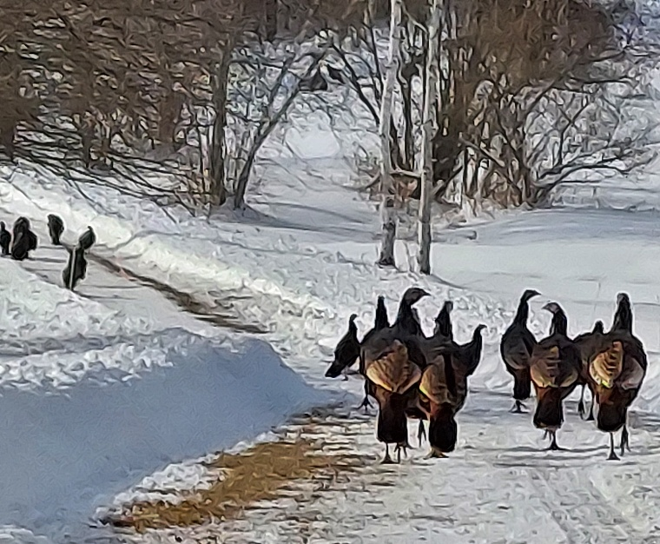

)

One World / One Communion
(Photo: Off West Road - David Mulholland)

Welcome, Announcements, Acknowledgement of Place
Prelude: Adagio in A Major Cesar Franck

-1-
* Call to Worship
Leader: Come, let us praise the Lord, who made the heavens and the earth, the seas and all that is in them (based on Psalm 146:6; Neh 9:6).
Left: We worship God who formed the beasts of the earth and every bird of the air
(based on Genesis 2:19).
Leader: The cattle on a thousand hills are the Lord’s, and every creature of the forest
belongs to God (based on Psalm 50:10–11).
Right: Let everything that breathes praise the Lord (based on Psalm 150:6).
All: We gather in joy and thanksgiving to honor the Creator of animals, who entrusted
them all to our care.

* HYMN 17: To You, O God, All Creatures Sing (Verses 1-3)
1. To you, O God, all creatures sing, And all creation, everything, Sing your praises, Alleluia!
Your burning sun with golden beam, Your silver moon with softer gleam, Sing your praises
Alleluia, Alleluia, Alleluia, Alleluia!
-2-
2. Your wind that blows the tempest by, your clouds that sail across the sky, sing your praises, Alleluia!
Your morning rises with a song, and lights of evening sing along, Sing your praises. Alleluia!
Alleluia, Alleluia, Alleluia, Alleluia!
3. Your flowing waters, crystal clear, make melodies for you to hear, Sing your praises, Alleluia!
Your fire, bountiful and bright, Remembering your warmth and light, Sing your praises, Alleluia!
Alleluia, Alleluia, Alleluia, Alleluia!

Prayer of Confession
Leader: Creator God, we confess that we have not always honored the earth you entrusted to our care. We pollute air and water, waste resources, and turn away from the cries of creation.
People: Forgive us, O God. Restore us to right relationships with all that you have made.
Leader: We confess that we have neglected creatures who share this world with us and
use them for our gain, ignore their suffering, and forget that all life reflects your goodness.
-3-
People: Forgive us, O Christ. Teach us to see animals great and small as companions in your creation.
Leader: We confess that we have failed one another—wounding our neighbors with indifference, overlooking the poor and the vulnerable, and valuing profit more than people.
People: Forgive us, Holy Spirit. Renew us in compassion and justice.
All: God of mercy, we seek your grace. Heal our hearts, mend your world, and guide us in the way of peace—so that earth, animals, and all people may live together in harmony,
singing your praise forever. Amen.
(Inspired by Gen 1:26–31; Psalm 24:1; Rom 8:19–23)

Assurance of Pardon: NCH #839
One fact remains that does not change: God has loved you, loves you now, and will love you always. This is the good news that brings us new life. AMEN.

*Gloria No. 756​ (As a round: unison, once; in parts, twice)
Gloria, gloria in excelsis deo
Gloria, gloria alleluia, alleluia!
-4-
Prayers of the People
L: May the Lord be with you.
P: And also, with you.
L: Let us pray.

Joys and Concerns / Silence / Pastoral Prayer

The Lord’s Prayer
Our Father/Mother/Creator, who art in heaven, hallowed be your name. Your kingdom come, Your will be done on earth as it is in heaven. Give us this day our daily bread and forgive us our trespasses as we forgive those who trespass against us. And let us not fall into temptation but deliver us from evil. For Yours is the kingdom, and the power, and the glory forever and ever. Amen.​

Scripture Lesson: Matt 21:33-46 The Parable of the Tenants
³³ “Listen to another parable: There was a landowner who planted a vineyard. He put a wall around it, dug a winepress in it and built a watchtower. Then he rented the vineyard to
some farmers and moved to another place. ³⁴ When the
harvest time approached, he sent his servants to the tenants
to collect his fruit.
-5-
³⁵ “The tenants seized his servants; they beat one, killed another, and stoned a third. ³⁶ Then he sent other servants to them, more than the first time, and the tenants treated them the same way. ³⁷ Last of all, he sent his son to them. ‘They will respect my son,’ he said.
³⁸ “But when the tenants saw the son, they said to each other, ‘This is the heir. Come, let’s kill him and take his inheritance.’ ³⁹ So they took him and threw him out of the vineyard and killed him.
⁴⁰ “Therefore, when the owner of the vineyard comes, what will he do to those tenants?”
⁴¹ “He will bring those wretches to a wretched end,” they replied, “and he will rent the vineyard to other tenants, who will give him his share of the crop at harvest time.”
⁴² Jesus said to them, “Have you never read in the Scriptures:
“‘The stone the builders rejected
has become the cornerstone;
the Lord has done this,
and it is marvelous in our eyes’?
⁴³ “Therefore I tell you that the kingdom of God will be taken
-6-
away from you and given to a people who will produce its fruit. ⁴⁴ Anyone who falls on this stone will be broken to pieces; anyone on whom it falls will be crushed.”^{[b]}
⁴⁵ When the chief priests and the Pharisees heard Jesus’ parables, they knew he was talking about them. ⁴⁶ They looked for a way to arrest him, but they were afraid of the crowd because the people held that he was a prophet.

Message: Tenant Rights or Staying Power

*Hymn 138: Jesus, Our Brother, Strong and Good French Medieval Carol
1. Jesus, our brother, strong and good, was humbly born in a stable rude,
And the friendly beasts around him stood; Jesus, our brother, strong and good.
2. “I,” said the donkey, shaggy and brown, “I carried your mother up hill and down,
I carried your mother to Bethlehem town; I” said the donkey, shaggy and brown.
3. “I,” said the cow, all white and red, “I gave you my
manger for you bed,
-7-
I gave my hay to pillow your head; I,” said the cow, all white and red.
4. “I,” said the sheep with curly horn, “I gave you my wool for a blanket warm,
You wore my coat on Christmas morn; I,” said the sheep with curly horn.
5. “I,” said the dove, from rafters high, “I cooed you to sleep so you should not cry,
We cooed you to sleep, my love and I; I,” said the dove, from the rafters high.
6. Thus, all the beasts, by some good spell, in a stable dark were glad to tell,
Of the gifts they gave Emmanuel, the gifts they gave Emmanuel.”
Offering of our Tithes and Pledges

Offertory: Allegretto Pastorale Walter Heaton

Praise God from whom all blessings flow!
​​Praise God, all creatures here below.
​Praise God for all that Love has done.
​​Creator, Christ, and Spirit, One.
-8-
*Prayer of Dedication

Celebration of Holy Communion

We celebrate an open table. When the moment to receive communion comes, all are welcome to come forward and share in the meal. If you are unable to walk forward but would like to participate, it will be brought to you. If you prefer not to receive communion, you are welcome to remain seated in quiet meditation.

Communion Interlude

*Hymn 31: All Things Bright and Beautiful (v.1,2,4)
Refrain:
All things bright and beautiful,
all creatures great and small,
all things wise and wonderful,
the Lord God made them all.

1 Each little flow'r that opens,
each little bird that sings,
God made their glowing colors,
God made their tiny wings. [Refrain]

2 The purple-headed mountain,
the river running by,
-9-
the sunset and the morning
that brightens up the sky. [Refrain]

3 The cold wind in the winter,
the pleasant summer sun,
the ripe fruits in the garden:
God made them every one. [Refrain]

*Commissioning and Benediction
Postlude: Arrival of the Queen of Sheba G.F. Handel

*Indicates that all who are able shall stand

Church and Community Notes
As we seek a settled pastor through our search and call process, we will not be able to offer office hours as usual, but the Deacons (Karen Blanchard, Lee Crocker, Charlotte Gifford, Adrienne Major, and Sue Venman) are available to support the congregation. You can leave a message on the church number (802-387-1175) or you can contact a deacon directly. In case of pastoral emergency, a deacon will call on the Rev. Shawn Bracebridge (pastor of the Dummerston
-10-
UCC) and help a person in need get in contact with him. For all questions of church building use, please contact Tom Griffith.
*************************************************
Worship Participants:
Service Leader: David Mulholland
Musician: Seth Phoenix
Deacons: Lee Crocker
Technician: Charlotte Gifford
Trustees: Guy Payne, chair
Ministers to the World: The Congregation

Upcoming Worship Leaders:
Oct 11: David Mulholland
Oct 18: Ray Huessy
Oct 25: TBD

-11-

